**Week 3 Assignments**

1)Distributed Web Applications

application consists of one or more local or remote clients that communicate with one or more servers on several machines linked through a network. With this type of application, business operations can be conducted from any geographical location.

Distributed applications run on multiple systems simultaneously for a single task or job.

Some distributed applications are actually two separate software programs: the back-end (server) software and the front-end (client) software.

For example, web browsers are distributed applications. Browsers require back-end software (servers on the World Wide Web as well as front-end software installed on your workstation (e.g., Netscape Communicator or Internet Explorer).

2)Client-Server Architecture

architecture of a [computer](https://www.britannica.com/technology/computer) [network](https://www.britannica.com/technology/computer-network) in which many [clients](https://www.britannica.com/technology/client) (remote processors) request and receive service from a centralized [server](https://www.britannica.com/technology/server) (host computer).

when the client computer sends a request for data to the server through the internet, the server accepts the requested, process it and deliver the data packets requested back to the client. One special feature is that the server computer has the potential to manage numerous clients at the same time. Also, a single client can connect to numerous servers at a single timestamp, where each server provides a different set of services to that specific client.

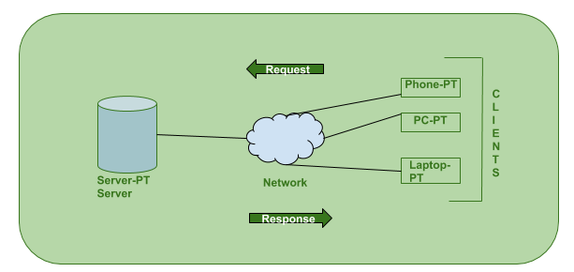

3)Client Side Scripting  
Source code is visible to user. Front-end

It usually depends on browser and it’s version.

It runs on user’s computer.

There are many advantages link with this like faster.   
response times, a more interactive application.

It does not provide security for data.

It is a technique use in web development in which scripts runs on clients browser.

HTML, CSS and javascript are used.

4)Server Side Scripting

Source code is not visible to user because it’s output of server side is a HTML page. Back-end

In this any server side technology can be use and it does not depend on client.

It runs on web server.

The primary advantage is it’s ability to highly customize, response requirements, access rights based on user.

It provides more security for data.

It is a technique that uses scripts on web server to produce a response that is customized for each clients request.

PHP, Python, Java, Ruby are used.

5)How the request made by the client will be processed by server and return back the response.

6)Http protocol  
an application-level protocol for distributed, collaborative, hypermedia information systems. This is the foundation for data communication for the World Wide Web (i.e. internet) since 1990. HTTP is a generic and stateless protocol which can be used for other purposes as well using extensions of its request methods, error codes, and headers.

* **HTTP is connectionless:** The HTTP client, i.e., a browser initiates an HTTP request and after a request is made, the client waits for the response. The server processes the request and sends a response back after which client disconnect the connection. So client and server knows about each other during current request and response only. Further requests are made on new connection like client and server are new to each other.
* **HTTP is media independent:** It means, any type of data can be sent by HTTP as long as both the client and the server know how to handle the data content. It is required for the client as well as the server to specify the content type using appropriate MIME-type.
* **HTTP is stateless:** As mentioned above, HTTP is connectionless and it is a direct result of HTTP being a stateless protocol. The server and client are aware of each other only during a current request. Afterwards, both of them forget about each other. Due to this nature of the protocol, neither the client nor the browser can retain information between different requests across the web pages.

7)http vs https

1. HTTP URL in your browser's address bar is http:// and the HTTPS URL is https://.
2. HTTP is unsecured while HTTPS is secured.
3. HTTP sends data over port 80 while HTTPS uses port 443.
4. HTTP operates at application layer, while HTTPS operates at transport layer.
5. No SSL certificates are required for HTTP, with HTTPS it is required that you have an SSL certificate and it is signed by a CA.
6. HTTP doesn't require domain validation, where as HTTPS requires at least domain validation and certain certificates even require legal document validation.
7. No encryption in HTTP, with HTTPS the data is encrypted before sending.

8)different http status codes

|  |  |
| --- | --- |
| 1 | **1xx: Informational**  It means the request has been received and the process is continuing. |
| 2 | **2xx: Success**  It means the action was successfully received, understood, and accepted. |
| 3 | **3xx: Redirection**  It means further action must be taken in order to complete the request. |
| 4 | **4xx: Client Error**  It means the request contains incorrect syntax or cannot be fulfilled. |
| 5 | **5xx: Server Error**  It means the server failed to fulfill an apparently valid request. |

9)why http is called as stateless protocol  
**HTTP** is called as a stateless protocol because each request is executed independently, without any knowledge of the requests that were executed before it, which means once the transaction ends the connection between the browser and the server is also lost.

10)http methods or verbs and difference between them.

|  |  |
| --- | --- |
| 1 | **GET**  The GET method is used to retrieve information from the given server using a given URI. Requests using GET should only retrieve data and should have no other effect on the data. |
| 2 | **HEAD**  Same as GET, but transfers the status line and header section only. |
| 3 | **POST**  A POST request is used to send data to the server, for example, customer information, file upload, etc. using HTML forms. |
| 4 | **PUT**  Replaces all current representations of the target resource with the uploaded content. |
| 5 | **DELETE**  Removes all current representations of the target resource given by a URI. |
| 6 | **CONNECT**  Establishes a tunnel to the server identified by a given URI. |
| 7 | **OPTIONS**  Describes the communication options for the target resource. |
| 8 | **TRACE**  Performs a message loop-back test along the path to the target resource. |

11)Web Server

1. On the hardware side, a web server is a computer that stores web server software and a website's component files. (for example, HTML documents, images, CSS stylesheets, and JavaScript files) A web server connects to the Internet and supports physical data interchange with other devices connected to the web.
2. On the software side, a web server includes several parts that control how web users access hosted files. At a minimum, this is an HTTP server. An HTTP server is software that understands [URLs](https://developer.mozilla.org/en-US/docs/Glossary/URL) (web addresses) and [HTTP](https://developer.mozilla.org/en-US/docs/Glossary/HTTP) (the protocol your browser uses to view webpages). An HTTP server can be accessed through the domain names of the websites it stores, and it delivers the content of these hosted websites to the end user's device.

|  |  |
| --- | --- |
| 1 | **Apache HTTP Server** This is the most popular web server in the world developed by the Apache Software Foundation. Apache web server is an open source software and can be installed on almost all operating systems including Linux, UNIX, Windows, FreeBSD, Mac OS X and more. About 60% of the web server machines run the Apache Web Server. |
| 2. | **Internet Information Services (IIS)** The Internet Information Server (IIS) is a high performance Web Server from Microsoft. This web server runs on Windows NT/2000 and 2003 platforms (and may be on upcoming new Windows version also). IIS comes bundled with Windows NT/2000 and 2003; Because IIS is tightly integrated with the operating system so it is relatively easy to administer it. |
| 3. | **Lighttpd** The lighttpd, pronounced lighty is also a free web server that is distributed with the FreeBSD operating system. This open source web server is fast, secure and consumes much less CPU power. Lighttpd can also run on Windows, Mac OS X, Linux and Solaris operating systems. |
| 4. | **Sun Java System Web Server** This web server from Sun Microsystems is suited for medium and large web sites. Though the server is free it is not open source. It however, runs on Windows, Linux and UNIX platforms. The Sun Java System web server supports various languages, scripts and technologies required for Web 2.0 such as JSP, Java Servlets, PHP, Perl, Python, and Ruby on Rails, ASP and Coldfusion etc. |
| 5. | **Jigsaw Server** Jigsaw (W3C's Server) comes from the World Wide Web Consortium. It is open source and free and can run on various platforms like Linux, UNIX, Windows, and Mac OS X Free BSD etc. Jigsaw has been written in Java and can run CGI scripts and PHP programs. |

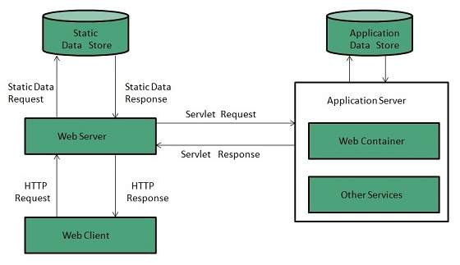

12)Application Server

13)Web Server VS Application Server

|  |  |  |
| --- | --- | --- |
| **Web Servers** | **Point of Comparison** | **Application Servers** |
| Hosts websites and responds to simple web requests | Main purpose | Hosts applications and delivers complex interactions through business logic |
| Only delivers static content via HTML | Type of content | Delivers static and dynamic content |
| HTTP/HTTPS protocols only | Protocols | The client-server interaction can occur via several protocols, including HTTP/HTTPS |
| No | Application connection | Yes |
| Has access to a static database | Database connection | Has access to the application database |
| Web browsers | Typical client | Serves web and mobile applications, and web browsers |
| Does not support multi-threading | Multi-threading | Uses multi-threading to process multiple requests in parallel |
| Facilitates traffic that does not consume a lot of resources | Resource consumption | Facilitates resource-intensive processes |
| Web container only | Containers | Web container (Servlets, JSP, JSF, web services), EJB container (JTA), Application Client container (DI, security) |
| Very low | Capacity | High |
| A hypertext document that displays information on a browser | Interaction result | Files that contain data and serve a specific purpose depending on the client needs |

14)JEE Architecture